|  |  |  |  |  |
| --- | --- | --- | --- | --- |
| **Credit Hours** | | | **Course Name** | **Code** |
| **Total** | **Practice** | **Lecture** |  |  |
|  |  |  |

**Clinic Management System**

|  |
| --- |
| **Student Name:** |
| **Student ID:** |
| **Level:** |
| **Department :** |

**Table of contents**

1. **Abstract ………………………………………………………….2**
2. **Introduction……………………………………………………...3**
3. **Theoretical analysis and discussion…………………………….4-9**

**3.1 System Description…………………………………………..4**

**3.2 Data Dictionaries…………………………………………….5**

**3.3 Entity Relationship Diagram………………………………..6**

**Abstract**

Clinical Management System is developed to support the daily operation of the clinic prior to this. It's done manually. This system will involve all clinical surgery, starting with the patient. Registration before the patient has been paid. The important thing is that it's going to be easier for the people Data recording and retrieval. This system will be able to generate a report on the clinic Business. For example, the number of patients per day and the total for the day. This one, the machine is in a position to review the inventory of the medication in the clinic. The target user for the system is staffed by the clinic, the doctor and also the management. The key to prototyping is used when designing this program. This will involve an iterative process to make this happen. The system is usable and user-friendly. The design of the system uses the System Life Cycle Creation (SDLC) strategy. The design will include the entity the relationship diagram (ERD) and the data flow diagram (DFD) to show the logical flow. The system In order to implement, it is necessary to make the program functional when designing any program. Overall, this system is capable of supporting day-to-day clinical surgery on the basis of Clear interface validation and the program is capable of executing the task correctly.

**Introduction**

Project clinical management is a program built to ease the contact process between the doctor and the receptionist. The software would be run by two administrators, one of whom is a doctor and the other is a receptionist. The Receptionist would be responsible for assigning token numbers to the patient visiting the clinic and saving them in the database along with their details. Such token numbers are sent to the doctor along with the corresponding patient information. The doctor can therefore view the details of the patient and, after checking the patient the recommended medicines for the particular patient are entered in the database by the doctor and sent to the receptionist. The receptionist can then generate the bill and feed it to the database. The system also maintains patient history so that the doctor or receptionist can view the patient at any time. As a consequence, the program will reduce the difficulty of managing health records.

In an era of technology, where everything needs to be done efficiently and effectively, the existence of the Clinical Management System (CMS) is becoming necessary. The use of CMS can enhance the services and workflow of all activities that take place in hospitals where it helps to reduce the workload of medical staff, the amount of manpower needed, and also make hospital management more manageable and easier to control. The Clinical Management System is window-based software designed for the registration and management of patient records and easy access to records. The program can be used to help the register, physicians, lab technicians and chemists store and maintain medical records in a hospital or clinic for better access and referral. Many of these operations are carried out on a daily basis and can be tedious for workers if performed manually, therefore providing reliable, easy-to-use management tools to help ease the workload for clinic / hospital personnel. There are already a large number of private and public hospitals who keep their patients in their accounts and process them manually. It's a very structured way of keeping documents and information, but the downside of storing data in this manner is that bad management of books will lead to a lack of data, books are not as safe and quickly perishable, and books with no back up until lost can't be recovered. Applying this system to such institutions will help to manage these records and preserve the information for longer periods of time, and will make it much easier and easier to access, as well as ensure the accuracy and transparency of the patient's details / records.

**Theoretical analysis and discussion**

**3.1 System Description:**

Our system's main target is to allow patients to remotely reserve in any clinic by providing them each day the empty appointments to not force them to go to the clinics to serve because many people may come from different distant places and may Waite for a lot of hours. Many of them their current status won't help them to stay for a long time. and because of the pandemic coronavirus, we have to reduce the gathering.so users can easily register to our system then login to their account to be able to make an appointment after that the employees in the clinic will display patients reservations per day and reply for them with the acceptance or refuse with a small message describing the reason for refuse and if they were accepted will send to their phone number and mail message with their appointment or the alternative appointment. Each patient also will be able to see his last history in this clinic. For the doctors that will be the admins in our system, they will be able to see the accepted reservations for the patients and profile each patient that enters for him, to know more about his healthstatus.Doctors also will be able to add, modify or delete any employeein the system

**Data Dictionaries**:

|  |  |  |  |
| --- | --- | --- | --- |
| Entities | attributes | Datatypes | Description |
| Doctors | ID  First Name  Last Name  Age  Years of Experience  Specialty  City  Address  Salary | Int  Varchar (60)  Varchar (60)  Double  Double  Varchar (60)  Varchar (60)  Varchar (60)  Varchar (60) | doctors will be able to enter their personal details through register screen and once they enter their data, they will be able to access their accounts through their emails and passwords |
| Employees | ID  Phone number  First name  Last name  Age  Address  Salary  Work hours  Years of experience | Int  Int  Varchar (60)  Varchar (60)  Double  Varchar (60)  Double  Double  Double | employees will be added to our system through a control panel by doctors to have an account by which they will access the system to manage the reservations |
| Patients | ID  First Name  Last Name  Email  Password  Phone number | Int  Varchar (60)  Varchar (60)  Varchar (60)  Varchar (60)  Int | Patients will register to our system to be able to see the system features and make reservations |
| Clinic | ID  Name  Location  Specialty  Phone number | Int  Varchar (60)  Varchar (60)  Varchar (60)  int |  |
| Reservation | Id  Day  Time | Int  Data time  Data Time |  |

**Entity Relationship Diagram:**

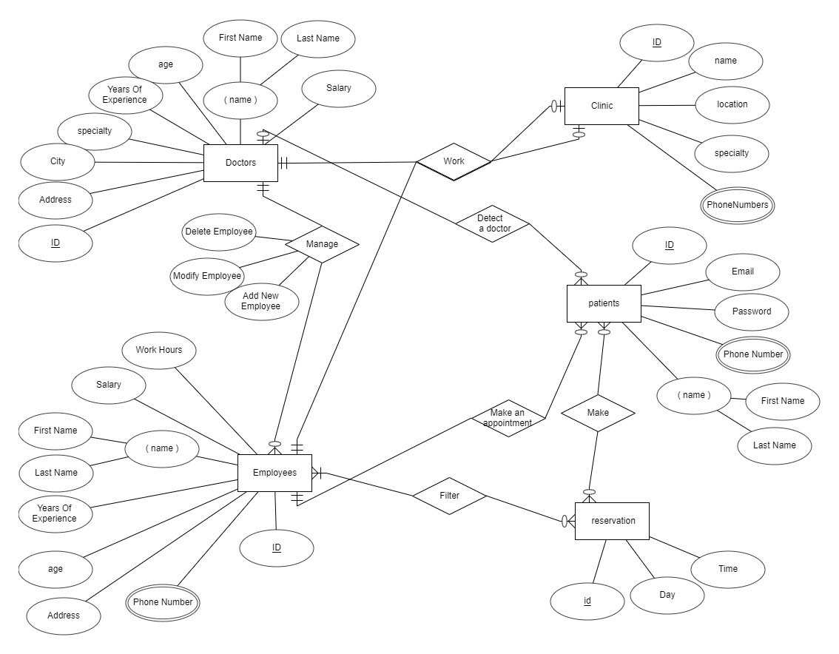

**Conclusion**

Finally, in the Clinic Management Program, this is the result of all the good work that has been performed on the clinical management system. It's a program that allows the patient to interact with the clinics quickly. This software reduces the number of manual data inputs and improves efficiency. The User Interface is very helpful and can be conveniently accessed by anyone. This also reduces the time required to write patient information and other modules. At the end of the day, we can say that this software performs all the tasks precisely and does the work it does.

The Clinical Management System is a computerized patient record system. The main purpose of the system is to reduce the burden on physicians and nurses and improve the management of patient records; our system integrates clinical, scheduling, electronic medical records, charts and data reporting components that enable clinics to provide quality care to patients. In addition, the new program would offer benefits to doctors and nurses. Most workload and preparation can be done more efficiently. The objective is to assist users in achieving their respective objectives and objectives.

**References**